

**“Student Database Management”**

***A***

***Project Report***

*submitted in partial fulfillment of the*

*requirements for the award of the degree of*

**BACHELOR OF TECHNOLOGY**

**in**

**COMPUTER SCIENCE & ENGINEERING**

**by**

|  |  |
| --- | --- |
| **Name** | **Roll No.** |
| **Syed Saif Rizvi** | **R164217057** |
| **Vidhi Mittal** | **R164217059** |
| **Yash Sharma** | **R164217062** |
| **SuyashChauhan** | **R134217166** |

***under the guidance of***

**Ms. Bhavana Kaushik**

**Assistant Professor, Department of Systemics**

**CANDIDATE’S DECLARATION**

I/We hereby certify that the project work entitled **“Student Database Management”** in partial fulfilment of the requirements for the award of the Degree of BACHELOR OF TECHNOLOGY in COMPUTER SCIENCE AND ENGINEERING with specialization in CYBER SECURITY & FORENSICS/INTERNET OF THINGS & SMART CITIES and submitted to the Department of Systemics at School of Computer Science, University of Petroleum & Energy Studies, Dehradun, is an authentic record of my/ our work carried out during a period from **January**, **2020** to **May**, **2020** under the supervision of **Ms. Bhavana Kaushik ,Assistant Professor, Department Of Systemics.**

The matter presented in this project has not been submitted by me/ us for the award of any other degree of this or any other University.

**(Syed Saif Rizvi, R164217057**

**Vidhi Mittal, R164217059**

**Yash Sharma, R164217062**

**Suyash Chauhan, R134217166)**

This is to certify that the above statement made by the candidate is correct to the best of my knowledge.

Date: 06/04/2020

**Dr. Neelu J. Ahuja**  **Ms. Bhavana Kaushik**

Head of the Department Assistant Professor

Department of Systemics Project Guide

**ACKNOWLEDGEMENT**

We wish to express our deep gratitude to our guide **Ms. Bhavana Kaushik**, for all advice, encouragement and constant support he has given us throughout our project work. This work would not have been possible without his support and valuable suggestions.

We sincerely thank to our respected Program Head of the Department, **Dr. Neelu J. Ahuja**, for his great support in doing our project.

We are also grateful to **Dr. Manish Prateek, Dean SoCS**, UPES for giving us the necessary facilities to carry out our project work successfully.

We would like to thank all our **friends** for their help and constructive criticism during our project work. Finally we have no words to express our sincere gratitude to our **parents** who have shown us this world and for every support they have given us.

|  |  |  |  |  |
| --- | --- | --- | --- | --- |
| **Name** | **Syed Saif Rizvi** | **Vidhi Mittal** | **Yash Sharma** | **Suyash Chauhan** |
| **Roll No.** | **R164217057** | **R164217059** | **R164217062** | **R134217166** |

**ABSTRACT**

Student Management System is software which is helpful for students as well as the school authorities. In the current system all the activities are done manually. It is very time consuming and costly. Our Student Management System deals with the various activities related to the students.

There are mainly 4 modules in this software

* Class module
* Subject module
* Exam module
* Student module

In the Software we can register as a user and user has of two types, student and admin. Admin has the power to add new user and can edit and delete a user. A student can register as user and can add edit and delete his profile.

The frontend website for the management system will be developed using NetBeans IDE and a backend using JAVA which will be controlled by the admin.

MySQL will be used to connect the front end to a database and different operation of MySQL is used to fetch and retrieve the data.

**TABLE OF CONTENTS**

**S.no. Contents Page No.**

1. **Introduction 7**

**2. System Analysis**

* Existing System 8
* Proposed System 9

1. **Literature Review 10-11**

1. **Objective 12**

1. **Methodology 13-14**
2. **Algorithm 15**

1. **Diagrams 16**
2. **Conclusion 17**
3. **Appendix 18-21**
4. **References 22**

**LIST OF FIGURES**

**S.No. Figure Page No**

1. Fig. 1 Structural Diagram of Student Management System 07
2. Fig. 2 Class UML Diagram 09

03 Fig. 3 Data Flow Diagram 10

**INTRODUCTION**

A student management system (also known as a student information system or SIS) helps a school manage data, communications, and scheduling. A school system generates and uses a large amount of data. This data must be communicated appropriately to students, faculty, and parents. A student management system helps schools to store, manage, and distribute this information.

Student Management System is a java project in NetBeans IDE. This system allows you to keep the student records and manage them when needed. This is a simple java project with good and interactive looking GUI. Some Features of this project are –

1. Class
2. Subject
3. Exam
4. Student

**SYSTEM ANALYSIS**

**EXISTING SYSTEM:**

In the current system we need to keep a number of records related to the student and want to enter the details of the student and the marks manually. In this system only the teacher or the school authority views the mark of the student and they want to enter the details of the student. This is time consuming and has much cost. Large amount of paper work is needed to accomplish the task in the current system and more time is needed to perpetuate necessary record. This system is used far and wide and it requires lot of human efforts and interaction is needed to maintain the records.

**PROPOSED SYSTEM:**

Existing system has encountered with many limitations. The suggested system hits the restrictions found in the existing system. In our proposed system we have the provision for adding the details of the students by themselves. So, the overhead of the school authorities and the teachers is become less. Another advantage of the system is that it is very easy to edit the details of the student and delete a student when it found unnecessary. The marks of the student are added in the database and so students can also view the marks whenever they want.

Our proposed system has several advantages

* User friendly interface
* Fast access to database
* Less error
* More Storage Capacity
* Look and Feel Environment
* Quick transaction

All the manual difficulties in managing the student details in a school or college have been rectified by implementing computerization.

# LITERATURE REVIEW

The [1] system has come up with many functionalities for educational institutions to track the student progress and managing attendance. It helps both student and guardian to keep track of student progress without visiting to the college. It also notifies student and guardian during the time of important events which are happening in institution. One more feature is guardian get alerted whenever student get failed in the exam or student not able to meet the expected attendance average. Student Information Report System (SIRS) is application software and which has intention to begin a conductive and direct interchanging the statistics in a secure platform to coalesce with students, faculties, parents and the college/school administration. The student information has the particulars (like register number sem, date-of-birth, sex, parent phone number, address, parent name, etc.) invade to the system by the faculties. All these particulars is stored in the database. SIRS application is trouble free to use in schools, colleges, universities, and any other educational institutions. It can be customized as per the need. It can be used in private and government educational institutions also. SIRS application is an internet-based application we can login to the system from anywhere irrespective of geographical area it will give seamless navigation. The paper [2] provides the particulars to carry out the performance, management and decision-making functions of enterprises or organizations. Enormous grow of students is caused to expand the functionality in the respective educational institutions. As student added to the educational system it is difficult to manage and track student details. To overcome difficulties, we come up with this new approach student information management system with additional features. This new approach will provide fast processing, efficient student tracking, and produces desired result. This approach will allow students to save their personal details. It is more secure, reliable and easy to use. Attendance [3] is part of any system to keep track of the particular person. It is mandatory process in educational system which directly reflects the student progress. In educational institutes attendance management is normally a manual process. There is enormous grow in the software industry which has privileged colleges to maintain the attendance system by using gadgets which is the best way. As we are using the smart phones, we not require maintaining attendance register. It can be easily done in mobile application. Faculty will be going to take the attendance when class gets started. They will initially login to the system through mobile application. Once attendance has been taken successfully for the class it will sent to sever through GPRS. The faculties can also do the necessary functions like registering new students, deleting the information about a particular student, modifying the information regarding the student etc. The main intention of this process is to reduce the risk of manual efforts. It also reduces the time consumption. Also we want to give importance to reduce the paper wastage that daily happens. The model [4] utilizes computer aided system. The model plays main role in an institution or in the college management. Initially, the system has developed with four layers based on the hierarchy such as Web display layer where application is deployed and displayed for end users. Business logic layer responsible for handling the functionality of the product. Data access layer is responsible for viewing the data. Database layer responsible for storing the student data. In Database layer ER diagram has been designed to provide data normalization. The process provides complete information about student, faculties and educational institution. Third thing in this project is to allowing user based on their categories. The paper [5] provides end user to seamless navigation to the application and ease of access. The model provides information management storing of student academic reports. This model consists of various functionalities like information about the courses available in the college starting from first grade to graduation. It also enables students to enroll to particular course through online, online fees payment, examination results, and also get notified when important events occur. All data stored and retrieved through the application is secure. So, to achieve this we have developed a powerful web based secured interface application which supports all type of request which are coming from the students also which gathers and corrects all student information. To achieve this, we have used similarity (Euclidean distance) algorithm. The results showed that the new information gathered by the SDS has the ability to fill the requirement and done the error correction in the traditional model. The papers [6] will explains how it is playing an important role in the education domain. This system is providing seamless access through the web-based application to access and manage different department or all over the organization. This system is used to mainly monitor the attendance for the university. Students are provided access to login to application and view the progress report and attendance report. This system is developed for an engineering college it will provide end users to maintain their data with minimum effort. Initially faculties/students get registered with the system once they finish registration process, they can access the system as well as they are able to do the changes in the data. As per the requirement users has been granted with certain level permission to manage and track the student information. Either student or faculty can upload and copy the statistics from the database. Since it is a web-based application which is accessible from any part of the world it has certain features like accessibility, easy to use. IOT, easy to manage etc. It is developed to suite the current environment which is rapidly growing in the student domain.

# OBJECTIVES

This project helps in maintaining the database of the students in any educational organization. We can easily access any students’ information anytime and can be kept safely for long period of time without any damage.

In this project we create a student database management system which interacts with students and teachers and they will be able to perform various operations in it.

We create this project by using NetBeans IDE for formatting and styling and Java for creating backend. MySQL is also used to connect with database.

# METHODOLOGY

Since, we are using the Incremental SDLC Model thus our methodology will be including all the phases of that model.

**System Feasibility: -** We will be analyzing the feasibility of our product that whether it will be implementable or not. This phase has already been completed during the title analysis.

**Software Plans & Requirements: -** During this phase we analyzed all the requirement sand planned the development cycle.

**Product Design: -** We will be developing use case in this phase to know what modules are needed for this product.

*This will mark the end of requirement verification

**Detailed Design:-** Here we will work on Level1 DFD to show sub modules and implementable functions. We will be also working on developing the required class diagram.

**Code: -** This will be our main phase which will be our implementation phase where we will code all the modules. Here we will also do the unit testing.

**Integration: -** This phase will aim at making the product out of the modules i.e. we will be merging the modules.

**Implementation: -** This will be our system testing phase. We will test all the merged modules. This will act as level one testing for our product.

**Operations & Maintenance: -** This is our last phase where will work towards achieving feedback and further improvements will be done accordingly.

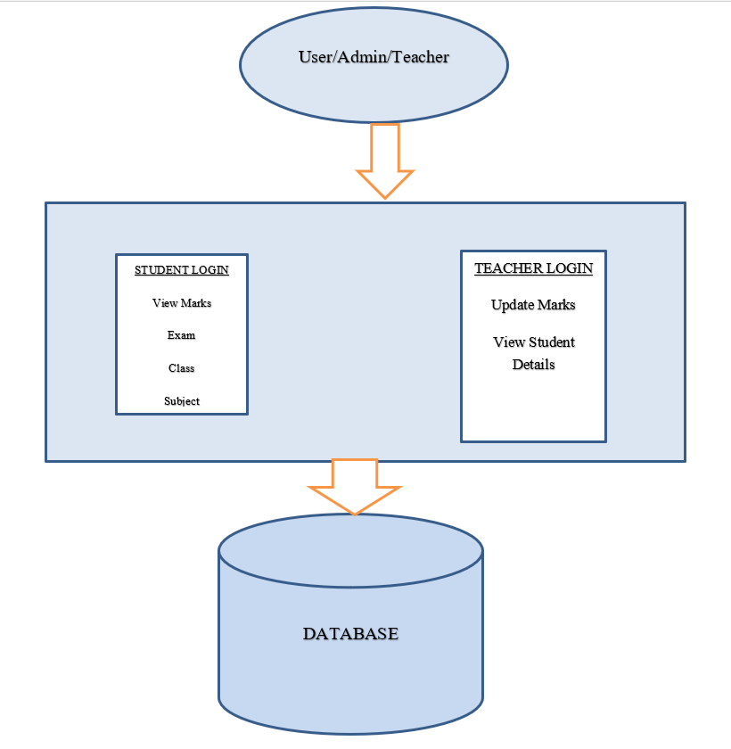

Fig.1: Structural Diagram of Student Management System

**ALGORITHM**

Step 1: Start

Step 2: Create a frontend page for login of the Students and Teachers.

Step 3: Create a database for student records using MySQL.

Step 4: For connection use servlets.

Step 5: Create tables login table with user details.

Step 6: Use primary and foreign key for connecting these tables.

Step 7: Enter id to view the details and performance of student.

Step 8: Display the result according to their performance.

Step 9: Stop

**Class UML Diagram**

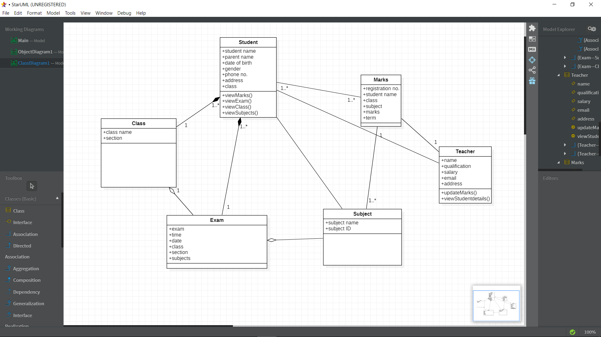

Fig.2 Class UML Diagram for Student management system

**Data Flow Diagram**

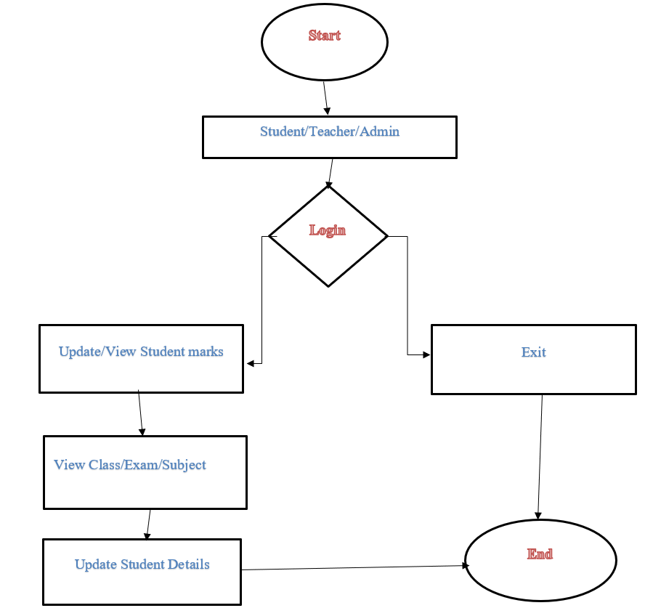

# Fig.3 Data flow diagram for student management

# Conclusion

# Student Management System is very useful in an institution or in college or in universities. There is no paper work in this proposed system. Supervision can be done from anywhere. This project especially minimizes human effort necessary. This application is handled by the college so there is no information leak and data will be secured. Since it is a web-based application anyone can use the system anywhere at any time and it is very easy to get the necessary information without the latency. It is very useful to the students to get their report on attendance and internal assessments. Parents also get benefited more since college is going to send the notification of the student via the SMS or email will be sent to get the recent activities happen in the college. Since this application will be handled by the college whenever they need any changes in an application, they can make it without the upfront investment, and the system will be more secure when it is handled by the own college.

# APPENDIX

# WhatsApp Image 2020-03-30 at 12.31.33 AM.jpeg

# WhatsApp Image 2020-03-30 at 12.31.57 AM.jpeg

# WhatsApp Image 2020-03-30 at 12.32.10 AM.jpeg

# WhatsApp Image 2020-03-30 at 12.33.13 AM.jpeg

# WhatsApp Image 2020-03-30 at 12.34.02 AM.jpeg

# WhatsApp Image 2020-03-30 at 12.34.19 AM.jpegWhatsApp Image 2020-03-30 at 12.34.47 AM.jpeg

# REFERENCES

# 

[1]. Isbudeen Noor Mohamed, Ahmad Tasnim Siddiqui, Syed Ajaz, S. Mohamed Idhris, “Student Information Report System with SMS (SIRS)”, in proc. 2016 International Conference on Computer Communication and Informatics (ICCCI -2016), Jan. 07 – 09, 2016, Coimbatore, INDIA.

[2]. FU Yue, “A Study of Student Information Management Software”, pp.393-396.

[3]. Freya. J. Vora, Pooja. L. Yadav, Rhea. P. Rai, Nikita. M. Yadav, “Android Based Mobile Attendance System”, International Journal of Advanced Research in Computer Science and Software Engineering, Volume 6, Issue 2, February 2016, pp.369-371.

[4]. Liangqiu MENG, “College Student Management System Design Using Computer Aided System” in proc. 2015 International Conference on Intelligent Transportation, Big Data & Smart City, pp.212-215.

[5]. Almahdi Alshareef, 1Ahmed Alkilany “Toward A Student Information System for Sebha University, Libya”, Fifth international conference on Innovative Computing Technology, 2015, pp.34-39.

[6]. Lalit Mohan Joshi, “A Research Paper on College Management System”, International Journal of Computer Applications (0975-8887) Volume 122 – No.11, July 2015, pp.32-44.

* http://www.javaworld.com/javaworld/jw-01-1998/jw-01-bookreview.html
* Database Programming with JDBC and Java by O'Reilly
* Head First Java 2nd Edition
* http://www.jdbc-tutorial.com/
* https://www.techopedia.com/definition/24735/netbeans
* Java and Software Design Concepts by APress

## Report verified by

**Project Guide HOD**

**(Department of Systemics)**

Ms. Bhavana Kaushik Dr. Neelu J. Ahuja